**Luis Munoz**

**Client2Command1**

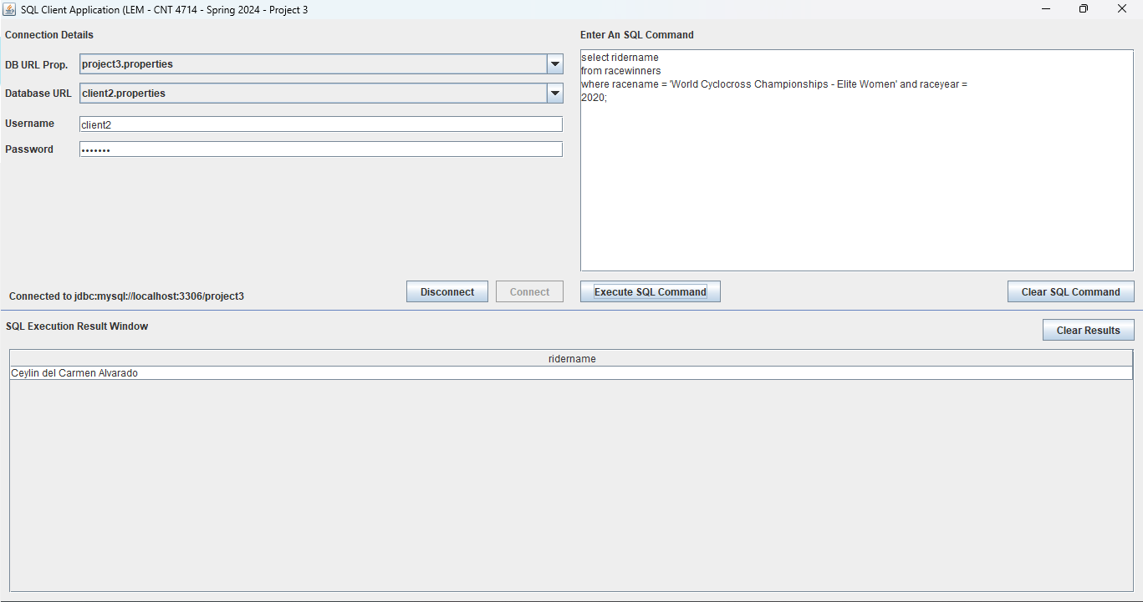

**Client2Command2A**

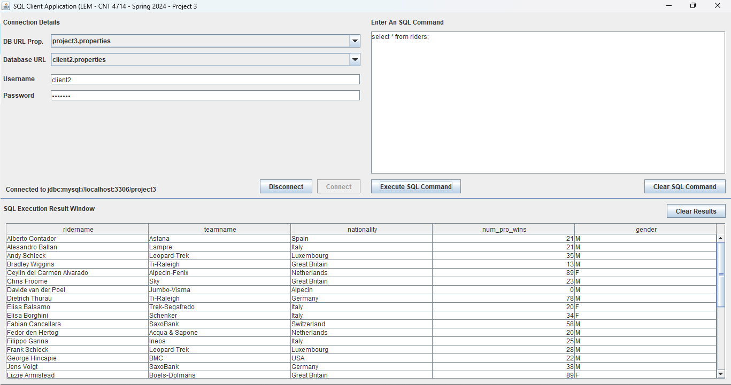

**Client2Command2B**

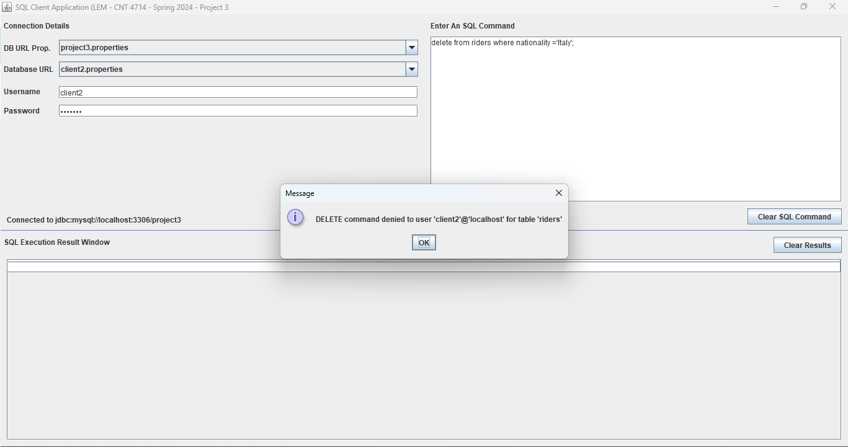

**Client2Command2C**

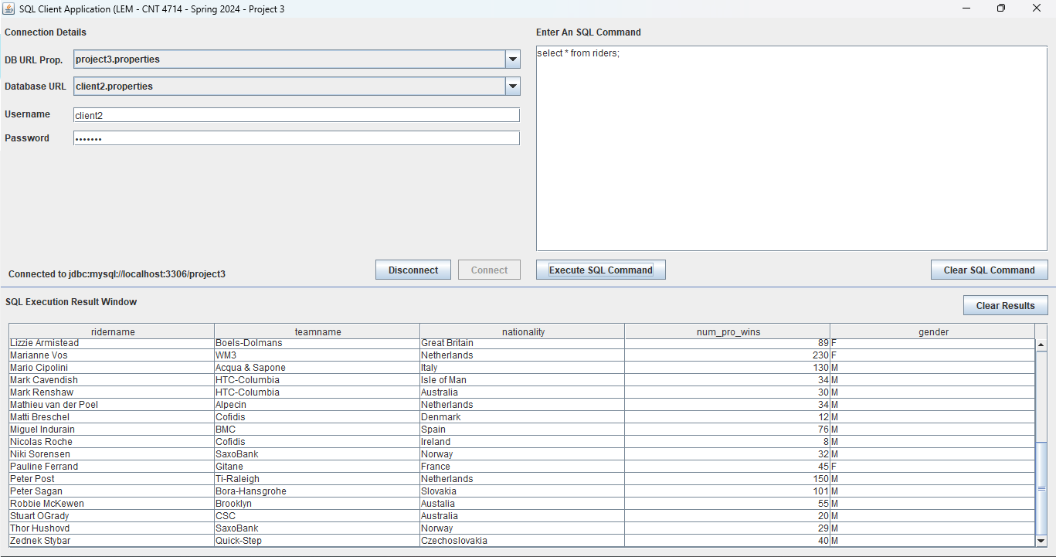

**Client2Command3A**



**Client2Command3B**

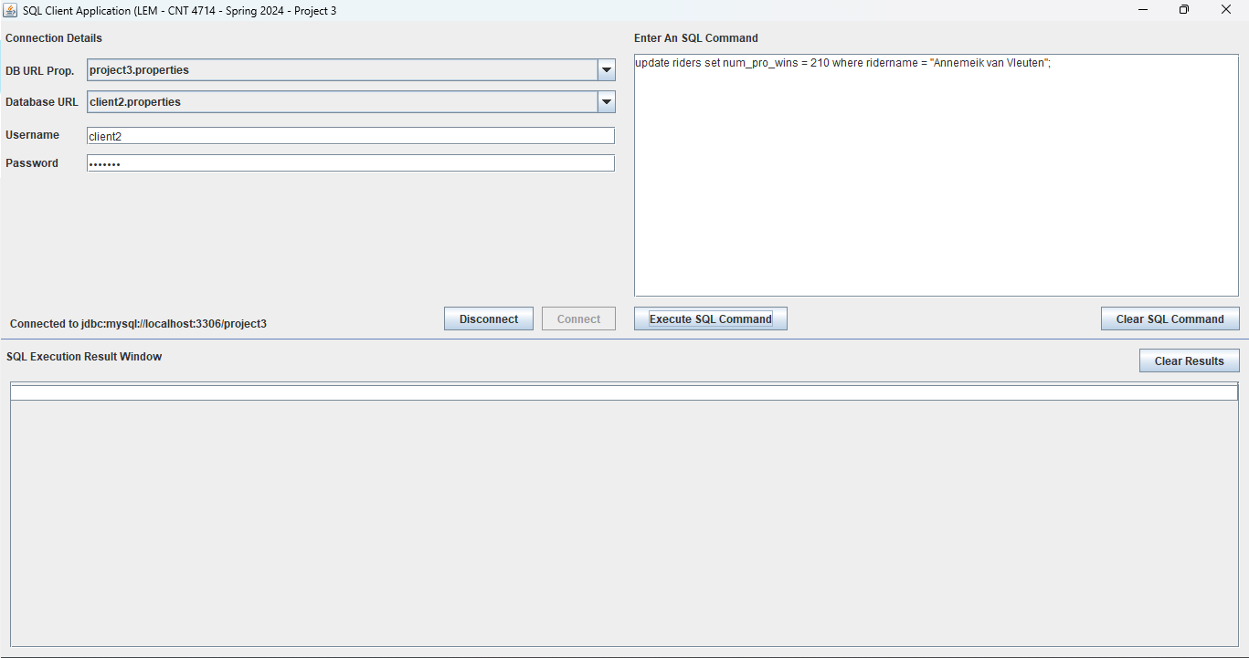

**Client2Command3C**



**Client2Command4**

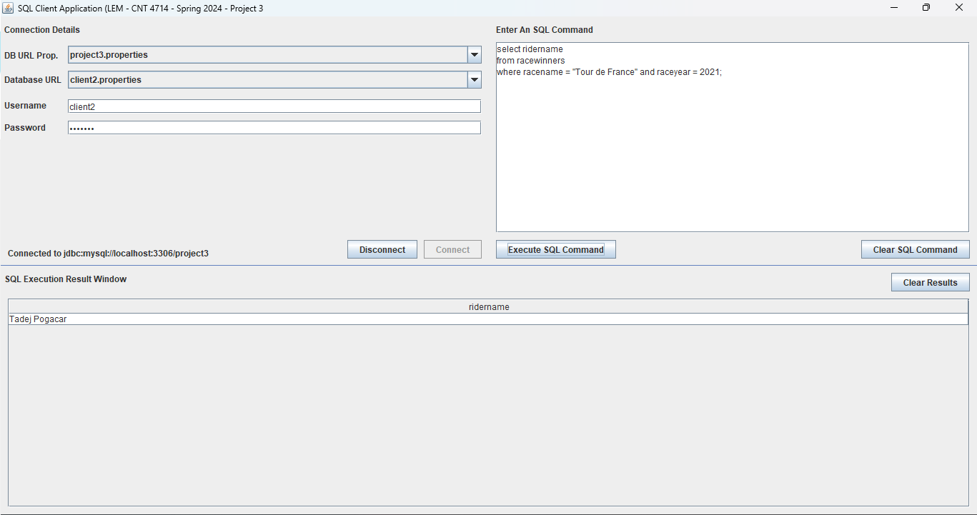

**Client2Command5**

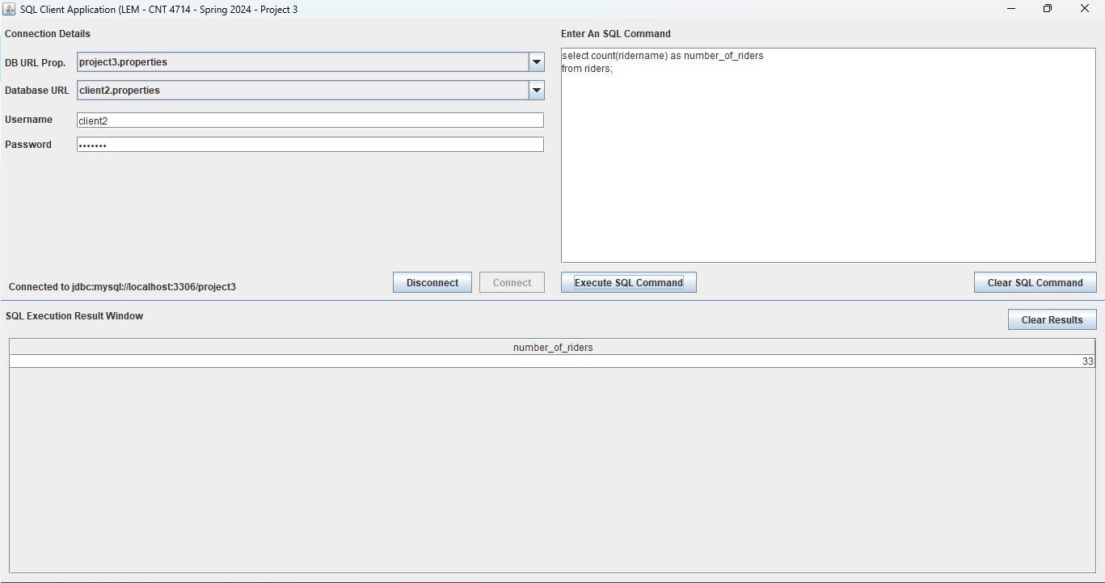

**Client2Command6**

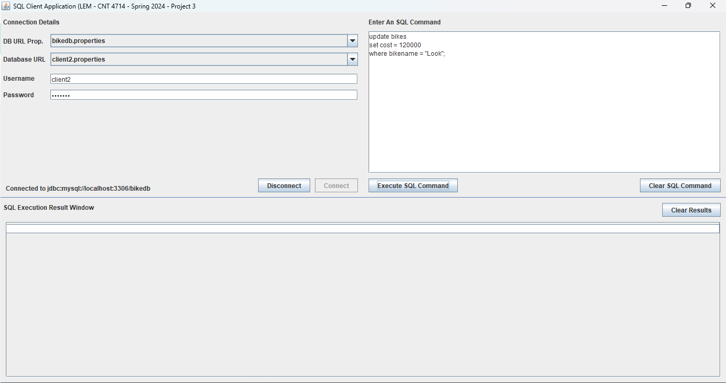

**Client2Command7**

